**Django project Version 2 Notes**

Creating a Webpage

---------------------------------------------------------------------------------------------

What happens when User goes to url path

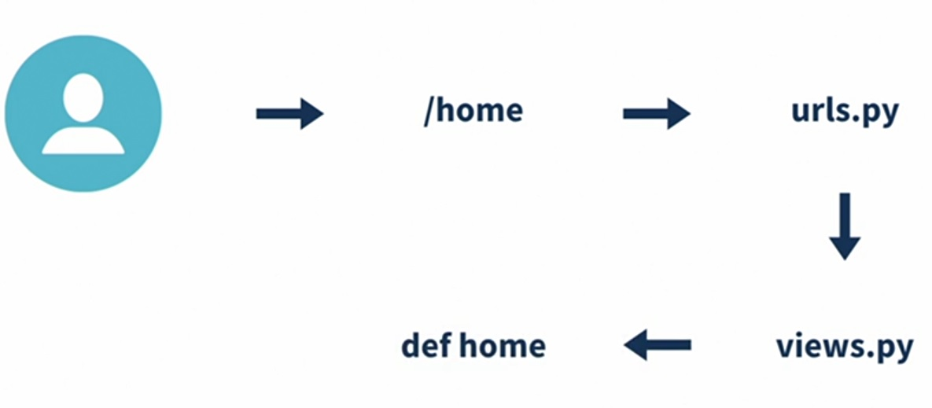

**STEP 1 - Create a View**

1. Go to app folder (“home”) > views.py
2. Import django.http from HttpResponse
   1. from django.http import HttpResponse
3. Create a View function
4. def home(request):
   1. return HttpResponse(‘Hello World!’)

* Everytime this view receives a request, it returns a response of “Hello World!”
* Views handle requests and responses

What your home page’s view should look like:

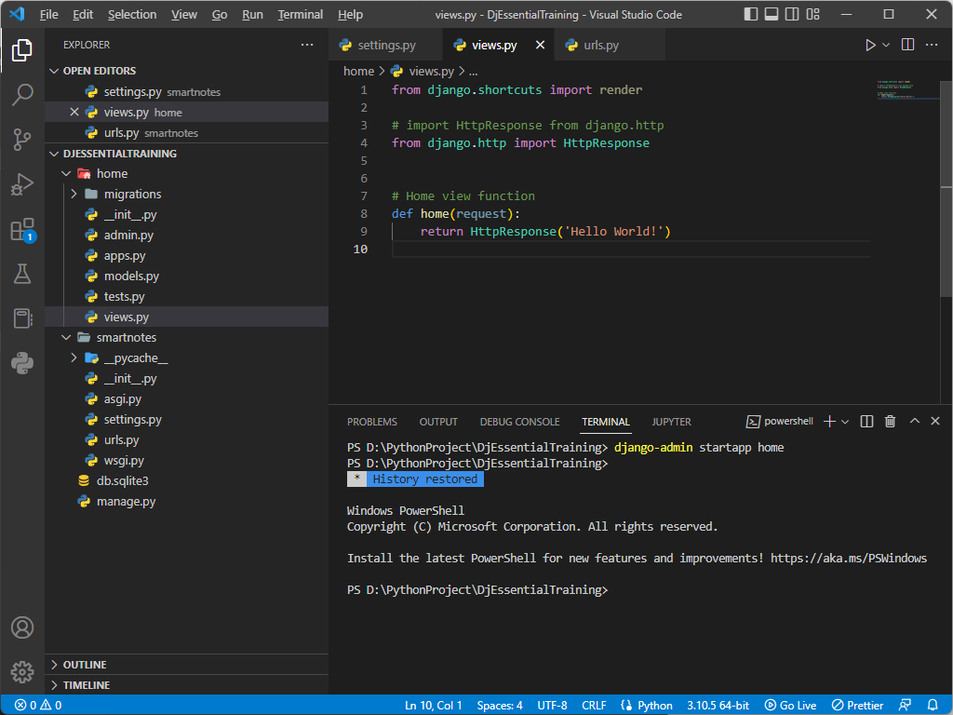

**STEP 2 - Create a URL Path**

1. Got to project folder (“smartnotes”) > urls.py
2. Import app folder (“home”) > views.py to urls.py
   1. from home import views
3. Add a new path to urlpatterns
   1. path(‘home’, views.home)

What your home page’s URL path should look like:

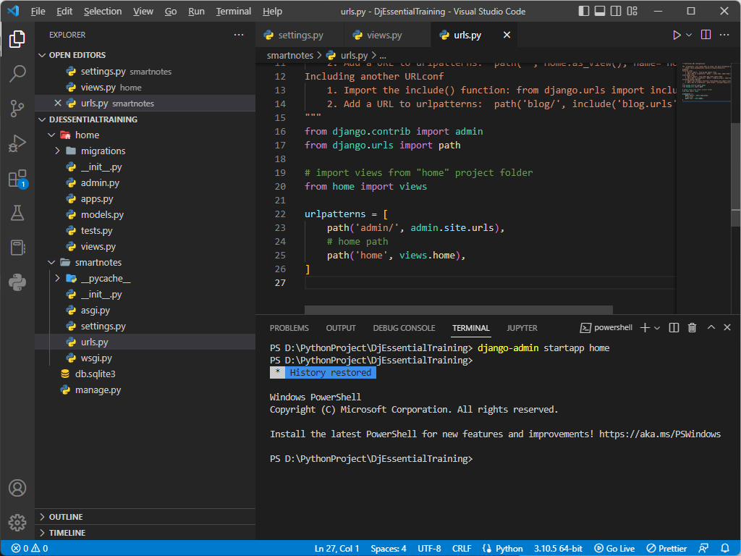

**STEP 3 - Create a Template**

1. Create a new folder “templates” in app folder “home”
2. Create a new folder with the same name as app “home” in templates folder
3. Create a new file “welcome.html” in templates > home folder
4. Add basic HTML to the page like the following:

<html>

<header><title>SmartNotes!</title></header>

<body><h1>Welcome to SmartNotes!</h1></body>

</html>

What the browser will show at port 8000:

Both admin and newly created “home” url paths are shown

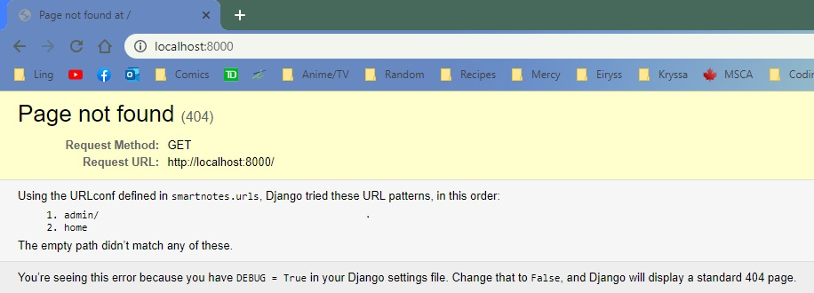

What the browser shows at “home” url path

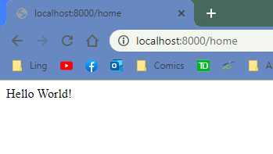

**STEP 4 - Render HTML**

1. Go to app folder (“home”) > views.py
2. Change the “home” view function’s body from an Http Response to render the HTML file
   1. def home(request):
      1. return render(request, ‘home/welcome.html’, {})

* Pass the original request, name of the template, and empty brackets
* The brackets are used to pass data from the view to the template

What your views.py should look like after adding the render statement

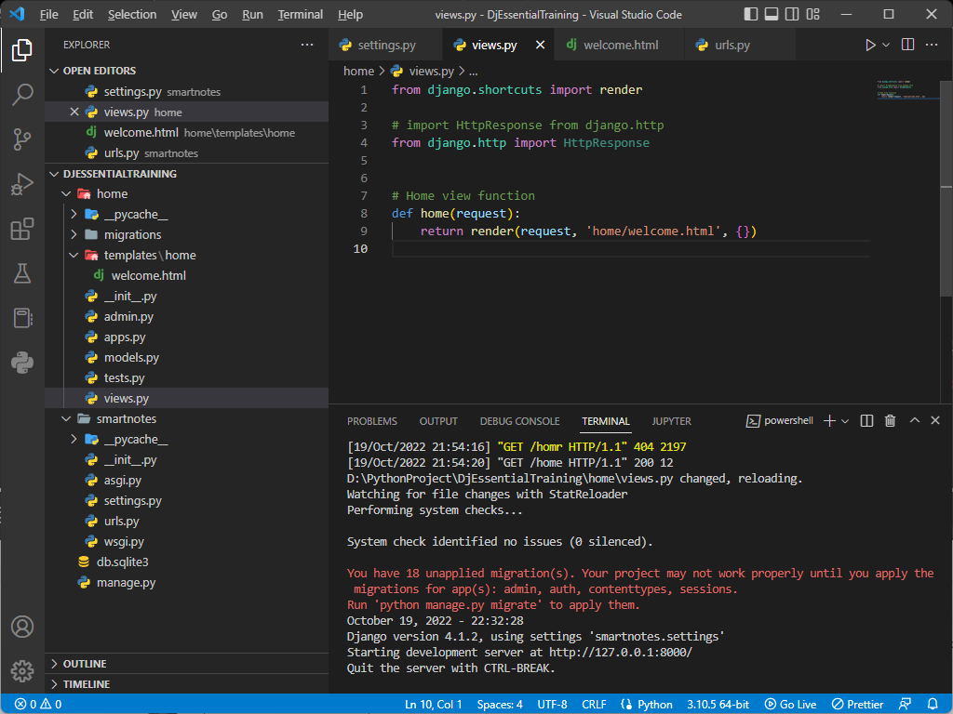

What your browser should show after rendering the html file in views.py

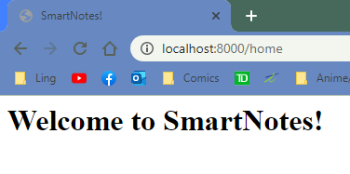

**Step 5 - Display The Date in Browser**

1. Go to app folder (“home”) > views.py
2. Import datetime module
   1. from datetime import datetime
3. Pass today’s date in in the dictionary with the key ‘today’
   1. return render(request, ‘home/welcome.html’, {‘today’ : datetime.today()})
4. Go to app folder (“home”) > templates > welcome.html
5. Pass the datetime dictionary value in a <p> tag
   1. <p>Today is {{today}}</p>

What your views.py should look like while passing dictionary with datetime

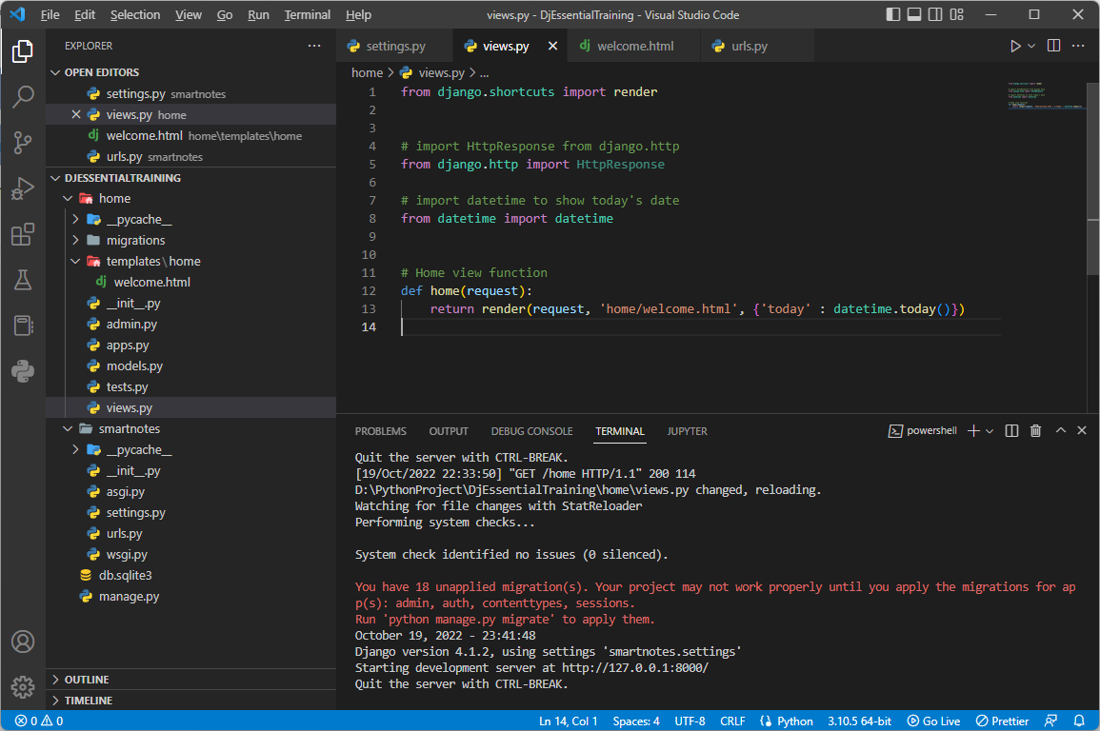

What your welcome.html should look like while passing the value for ‘today’

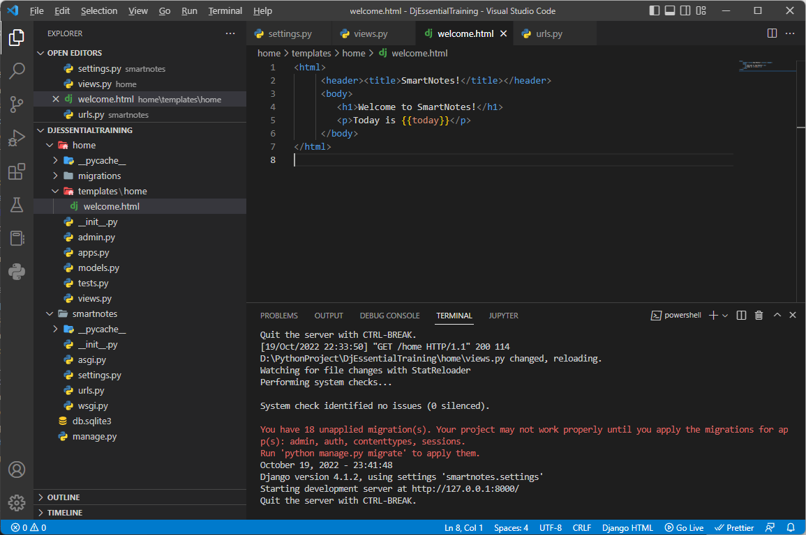

What your browser should show afterwards

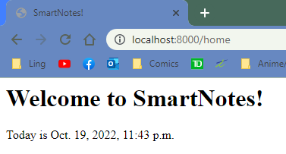

**STEP 6 - Remove Dependency Between Django Project and Django App**

1. Create new file “urls.py” in app folder (“home”)
2. Add code similar to what is in the project folder (“smartnotes”) > urls.py
   1. Import django path urls
   2. Import app’s views
   3. Add urlpatterns
3. Remove the dependencies from project folder (“smartnotes”) > urls.py
4. In project folder (“smartnotes”) > urls.py import include from django urls
   1. From django.urls import path, include
5. In project folder (“smartnotes”) > urls.py create a path for app folder (“home”) urls
   1. path(‘’, include(‘home.urls)),

What your new urls.py file should look like:

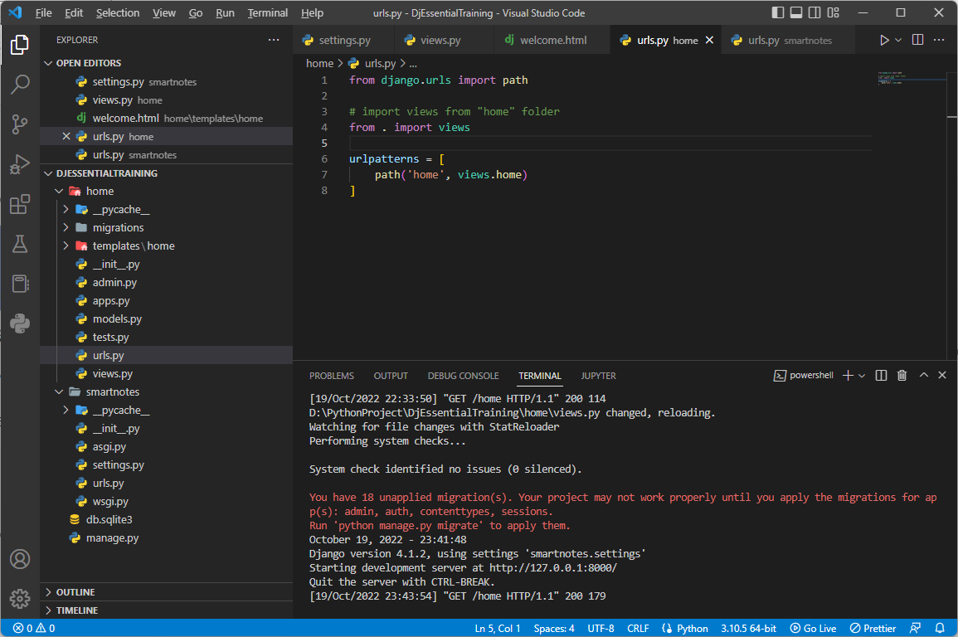

What project folder (“smartnotes”) > urls.py should look like:

